**Learning Theory Carnival**

Monday, July 22

7:15-9:15 pm

**PROTOCOL**

**BOOTH Four**

**Who Needs Vygotsky?**

|  |  |
| --- | --- |
| **Learning GOAL:**  **Participants increase their knowledge of abolitionism and learning theory by engaging in a Vygotskyan process of intersubjectivity with peers.** | |
| **Directions**   1. **Observe poster of constructivism and zero in on VYGOTSKY** 2. **Direction: We are going to pick cards of abolitionists and discuss in pairs. After we finish, we are going to talk about the components of Vygotskyan theory that are represented by the activity.**   ***First let’s activate prior knowledge -- ASK: What do you currently know about abolitionism or abolitionists? Discuss in pairs.***   1. **Demonstrate by choosing one person as partner and summarizing one card and asking questions to support the person’s learning like**   **Example (Samuel Ringgold Ward)**  *Samuel Ward was born an enslaved person and was able to escape with his parents and move to NY. Like Frederick Douglass, he was an orator who supported the anti-slavery cause, eventually becoming a pastor and later involved in the Anti-Slavery society. Fear of becoming re-enslaved, he moved to Canada and then Jamaica where he died at age 49 in 1866.*  **What facts about Ward are most of interest to you?**  **What would you like to know more about?**   1. **Every person picks a card, reads and formulates a summary.** 2. **Pair persons a second time and have them discuss information from card.** 3. **To debrief, talk about the elements of Vygotsky that are present in this activity and how your learning was supported by a peer.** 4. **STAMP/GIVE STICKER (?) the CARNIVAL BOOKLET** | |
| **Activities**   1. **The group observes the poster of constructivism. Ask: What do you observe about Vygotsky’s contribution to constructivism? Activate prior knowledge by asking question.** 2. **Each person gets a card and prepares summary.** 3. **Pairs discuss summaries.** 4. **Group discusses how this represents Vygotsky and why we need this theory in our understanding of learning – particularly intersubjectivity (social interaction), using paraphrasing and language to support learning, and how this is social construction of knowledge.** | **Materials**   * **Poster of Constructivism** * **Abolitionist CARD DECK** |

[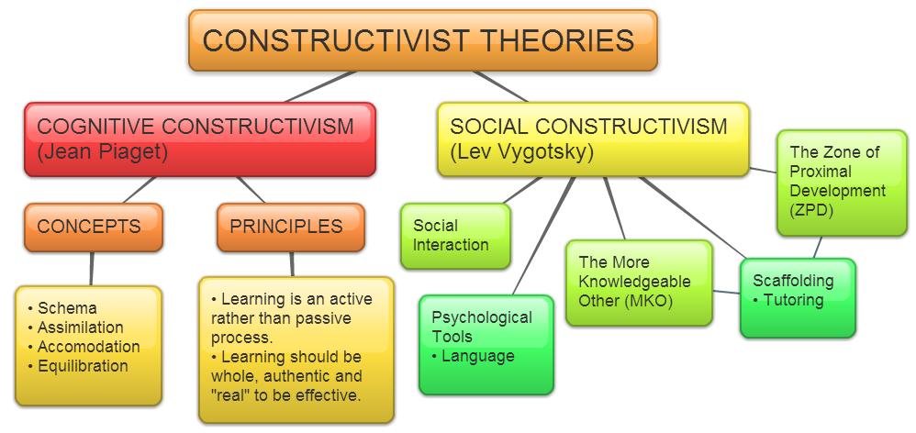](https://owelpapel.wordpress.com/tag/notes-and-resources/)